|  |
| --- |
| Circle Language Spec: Commands |

## A Call in a Call Shows Privates When Running

A call inside another call only contains its private content when it is actually running. If a call is not running, then you would have to hop to the definition of a call to see the private contents of the command.

Not creating a call’s private contents before it even runs, takes away discussion about when to display and when not to display a command’s private contents.

### In a Diagram

A call inside another call only contains its private content when it is actually running.

If a call is not running:

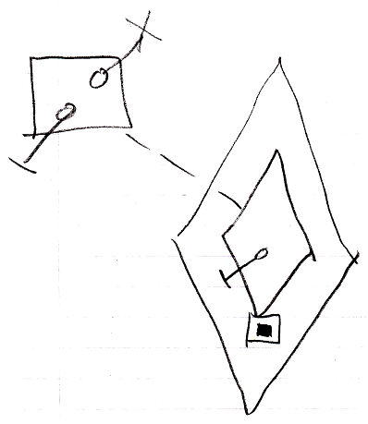

Then you would have to hop to the definition of a call to see the private contents of the command.

When a call is running, you do see its private contents:

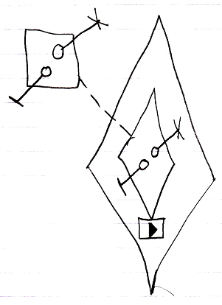

Not creating a call’s private contents before it even runs, takes away discussion about when to display and when not to display a command’s private contents.